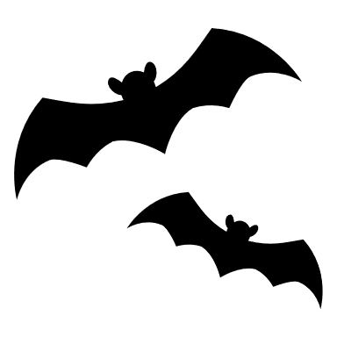
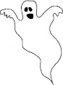
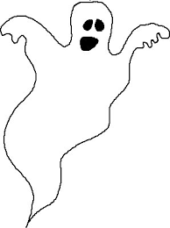
2022 Halloween Décor Contest
Email your finished scorecard to amy@downtownsb.org
 | Business | Side of State | Address | Score (1-5) (5 = best) | Notes
1 | Taza Mediterranean Kitchen | L | 413 State Street
2 | State Street Axe Club | L | 427 State Street
3 | Whiskey Richards | L | 435 State Street
4 | Red Piano | L | 519 State Street
5 | Hotel Santa Barbara | L | 533 State Street
6 | Dr. Hurtado Dentistry | L | 605 State Street
7 | M.Special Brewing Co. | R | 634 State Street
8 | 33 Jewels | R | 814 State Street
9 | Vuori Clothing | L | 833 State Street
10 | Blue Owl | L | 5 W Canon Perdido
11 | The Crafter's Library | R | 9 East Figueroa Street
12 | Pu’u Muay Thai Santa Barbara | L | 1107 state street
13 | Renaissance Consignment | R | 1118 State Street
14 | Unity Shoppe | L | 1209 State Street
15 | Renaissance Consignment | R | 1118 State Street
16 | Unity Shoppe | L | 1209 State Street
17 | Sportsman | R | 1226 State Street
18 | The Barber Shop | L | 1233 State Street
19
20
21
22
23
24
25
26
27
28
29
30
31
32
33
34
35

